MFC – 4 ASSIGNMENT – 6

SHRUTHI RENGARAJAN

BATCH: B

CB.EN.U4AIE22154

*Code:*

clc; clear variables; close all;

img = imread("D:\AMRITA\Sem4\MFC4\Assignment6\Image.jpeg");

img = rgb2gray(img);

img = imresize(img, [50, 50]);

img = reshape(img,[],1);

act_Size = size(img);

n = act_Size(1);

p = 500;

C = randn(p, n);

theta = C*dctmtx(n) ;

y = C * double(img);

cvx_begin

variable s(n)

minimize ( norm(s, 1) )

subject to

norm(y - theta*s, 2) <= 0 ;

cvx_end

% Reconstruct the image

s_resz = dctmtx(n) * s;

s_resz = reshape(s_resz, [50, 50]); % Reshape to image size

s_resz = uint8(s_resz); % Convert to uint8 format

subplot(2, 1, 1)

imshow(reshape(img, 50, 50))

subplot(2, 1, 2)

imshow(s_resz)

%%

cvx_begin

variable s1(n)

minimize ( norm(s1, 1) )

subject to

theta*s1 == y ;

cvx_end

% Reconstruct the image

s_resz1 = dctmtx(n) * s1;

s_resz1 = reshape(s_resz1, [50, 50]); % Reshape to image size

s_resz1 = uint8(s_resz1); % Convert to uint8 format

subplot(2, 1, 1)

imshow(reshape(img, 50, 50))

subplot(2, 1, 2)

imshow(s_resz)

%%

subplot(3,2,1)

plot(s)

title('L1')

ylim([-.2 .2])

grid on

subplot(3,2,[3 5])

[hc, h] = hist(s, [-.1:.01: .1]);

bar(h,hc,'r')

axis([-.1 .1 -20 1000]);

subplot(3,2,2)

plot(s1)

title('L2')

ylim([-.2 .2])

grid on

subplot(3,2,[4 6])

[hc, h] = hist(s, [-.1:.01: .1]);

bar(h,hc,'r')

axis([-.1 .1 -20 1000]);

%%

s_pinv = pinv(C * dctmtx(n)) * y;

subplot(2,1,1)

plot(s_pinv)

title('L2')

ylim([-.2 .2])

grid on

subplot(2,1,2)

[hc, h] = hist(s_pinv, [-.1:.01: .1]);

bar(h,hc,'r')

axis([-.1, .1, -20, 1000]);

%%

s_resz = dctmtx(n)'*s;

s_resz = reshape(s_resz, [50, 50]); % Reshape to match the original image size

s_resz = uint8(s_resz);

imwrite(s_resz, 'D:\AMRITA\Sem4\MFC4\Assignment6\image_1.jpg');

s_resz = dctmtx(n)'*s1; % Corrected variable name

s_resz = reshape(s_resz, [50, 50]); % Reshape to match the original image size

s_resz = uint8(s_resz);

imwrite(s_resz, 'D:\AMRITA\Sem4\MFC4\Assignment6\image_2.jpg');

s_resz = dctmtx(n)'*s_pinv;

s_resz = reshape(s_resz, [50, 50]); % Reshape to match the original image size

s_resz = uint8(s_resz);

imwrite(s_resz, 'D:\AMRITA\Sem4\MFC4\Assignment6\image_3.jpg');

*Output:*

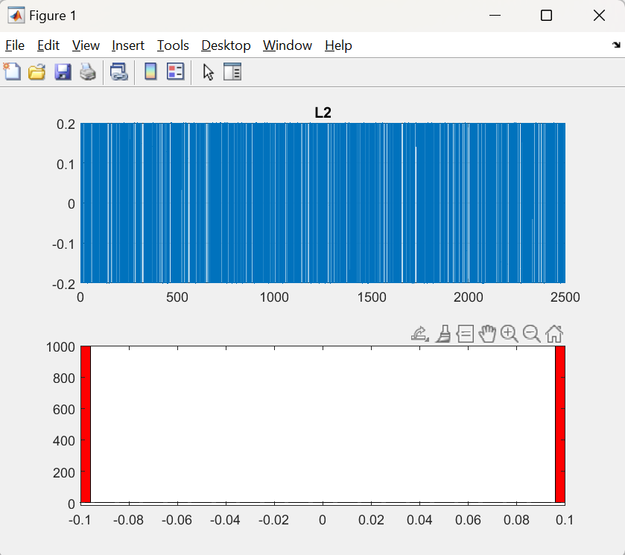

Input:  


Output:





